FLAG Christmas Quiz 2024
Section 1 History
- Before our estate was built there was a factory on the site. What was its name? What did it produce? Harris Lebus produced furniture (except during WW2)

- Three blocks of flats in Hale Village are called Vickers; Albermarle; and De Havilland. Why these names? Vickers and De Havilland made airplanes and Albermarle was a plane – Harris Lebus worked on them all during WW2

- The new block of flats above the Welbourne Health centre on Monument Way is called Walter Tull house. Who was Walter Tull?

  - First Black footballer to play for Spurs
  - First Black officer to be commissioned in the British Army
  - A footballer with a life size statue in the Guildhall in Northampton
He was all three.
Section 2 - Environment
- What endangered British mammal is found on our estate? Hedgehog

- How long is the River Lee? Is it
  - 60 miles
  - 25 miles
  - 42 miles is the correct answer

- Match the bird to the picture.
Grey Heron; Chaffinch; Egyptian Goose; Wood Pigeon; Robin; Little Grebe; Blue Tit; Ring-necked Parakeet; Great Tit; Crow; Goldfinch; Great Spotted Woodpecker see pictures below
Section 3 – Transport
- When did the station at Tottenham Hale first open? Was it
  - 1840 is the correct answer
  - 1872
  - 1966

- How many stations are there between Tottenham Hale and Oxford Circus 8 if you include both TH and OC, 7 if just OC.

- How many stations (under and overground) are there in the borough of Haringey? There are 15 in total (Highgate, Harringay, Harringay Green Lanes, Hornsey, Alexandra Palace, Crouch Hill, South Tottenham, Bruce Grove, White Hart Lane, Tottenham Hale, Seven Sisters, Northumberland Park, Wood Green, Turnpike Lane, and Bounds Green)

- How much are London bus fares due to rise in 2025? Zero bus fares have been frozen this year

Section 4 – local politics
- Who is our local MP? What is their position in the Government? David Lammy MP is the Foreign Secretary

- The ward boundaries changed recently. What is the name of our ward now?
  - Tottenham Central
  - South Tottenham is the correct answer
  - Tottenham Hale

- We have three local councillors. Can you name them? Cllr Sheila Peacock, Cllr Makbule Gunes and Cllr Mark Grosskopf

Section 5 – Sport and entertainment
- What is the name of the major music venue just north of Tottenham Hale?
  - Drumbeats
  - Dreadheads
  - Drumsheds is the correct answer

- How many gold medals did Great Britain get in the Olympics this year, was it
  - 14 is the correct answer
  - 8
  - 21
- How many medals in total did GB get?
  - 60
  - 63
  - 65 is the correct answer
- Who won series two of the Traitors?
  - Diane
  - Harry is the current answer
  - Zack
- Which country did Paddington visit this year? Peru

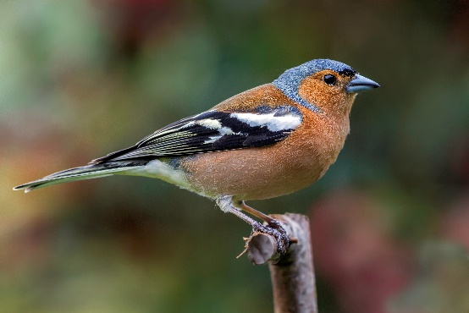 | 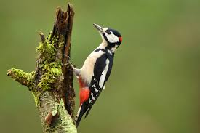 | 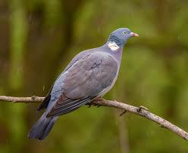
1 chaffinch | 2 great spotted woodpecker | 3 wood pigeon
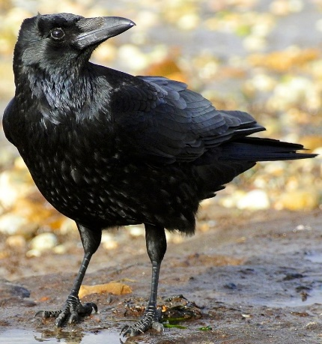 | 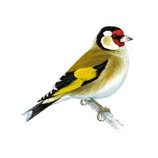 | 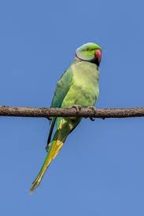
4 crow | 5 goldfinch | 6 ring necked parakeet
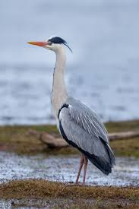 | 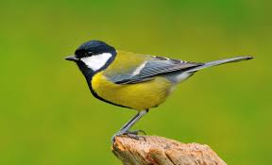 | 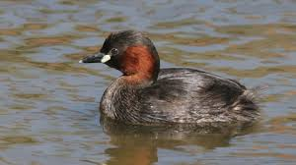
7 grey heron | 8 great tit | 9 little grebe
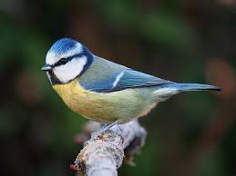 | 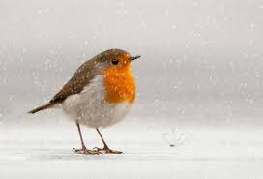 | 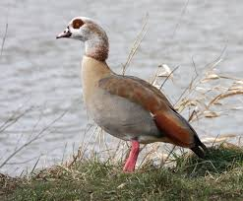
10 bluetit | 11 robin | 12 Egyptian goose

