FLAG Christmas Quiz 2024
Section 1 History
- Before our estate was built there was a factory on the site. What was its name? What did it produce?

- Three blocks of flats in Hale Village are called Vickers; Albermarle; and De Havilland. Why these names?

- The new block of flats above the Welbourne Health centre on Monument Way is called Walter Tull house. Who was Walter Tull?

  - First Black footballer to play for Spurs
  - First Black officer to be commissioned in the British Army
  - A footballer with a life size statue in the Guildhall in Northampton

Section 2 - Environment
- What endangered British mammal is found on our estate?

- How long is the River Lee? Is it
  - 60 miles
  - 25 miles
  - 42 miles

- Match the bird to the picture.
Grey Heron; Chaffinch; Egyptian Goose; Wood Pigeon; Robin; Little Grebe; Blue Tit; Ring-necked Parakeet; Great Tit; Crow; Goldfinch; Great Spotted Woodpecker
Section 3 – Transport
- When did the station at Tottenham Hale first open? Was it
  - 1840
  - 1872
  - 1966

- How many stations are there between Tottenham Hale and Oxford Circus

- How many stations (under and overground) are there in the borough of Haringey?

- How much are London bus fares due to rise in 2025?

Section 4 – local politics
- Who is our local MP? What is their position in the Government?

- The ward boundaries changed recently. What is the name of our ward now?
  - Tottenham Central
  - South Tottenham
  - Tottenham Hale

- We have three local councillors. Can you name them?

Section 5 – Sport and entertainment
- What is the name of the major music venue just north of Tottenham Hale?
  - Drumbeats
  - Dreadheads
  - Drumsheds

- How many gold medals did Great Britain get in the Olympics this year, was it
  - 14
  - 8
  - 21
- How many medals in total did GB get?
  - 60
  - 63
  - 65
- Who won series two of the Traitors?
  - Diane
  - Harry
  - Zack
- Which country did Paddington visit this year?

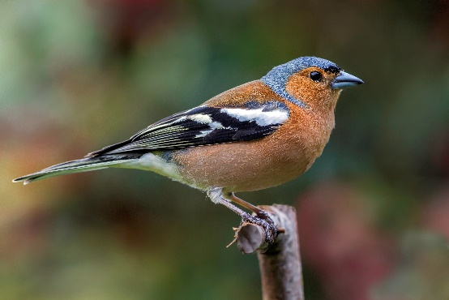 | 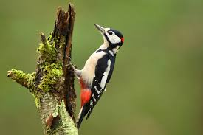 | 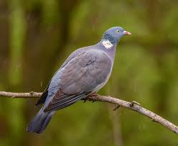
1 | 2 | 3
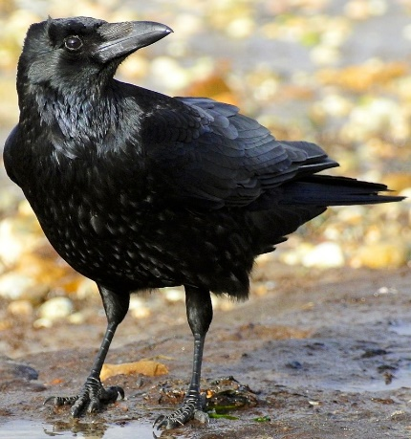 | 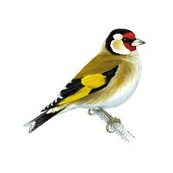 | 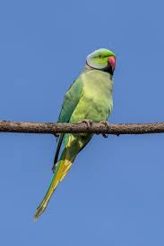
4 | 5 | 6
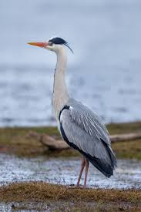 | 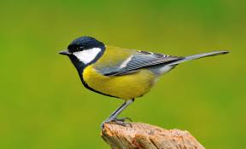 | 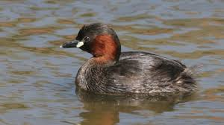
7 | 8 | 9
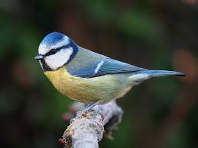 | 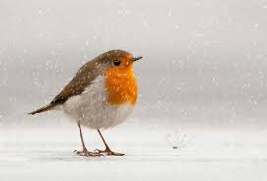 | 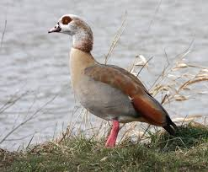
10 | 11 | 12

